SIMPLE PRESENT
WHAT´S YOUR DAILY ROUTINE?
- Look at the pictures and write the correct number for the actions below:
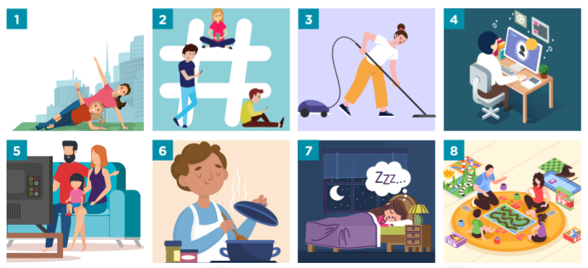
____ use the computer ____ cook
____ sleep ____ use the cell phone
____ watch television ____ clean the house
____ do gym __8_ play games

- Let´s find 8 everyday actions:
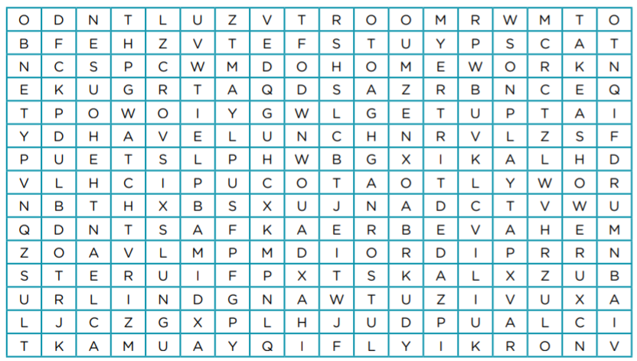
1._do homework 2.__________ 3.____________ 4._____________
5.___________ 6.__________ 7.____________ 8._____________
- Macarena is at home. She has many things to do along the day. Can you help her to organize her activities? Complete the chart below:
Play watch have lunch do homework have breakfast
09.00 | Get up | 17.00
09.15 |  | 20.30 | Take a shower
10.30 |  | 21.00 | Have dinner
13.00 |  | Free time
14.15 | Clean the house | Free time | Use the cell phone

- Macarena is sending a whatsapp to Sofía, her best friend, about what she does at home. Complete the text with the activities on exercise 3:
Hi Sofi! I __________________ at 9 o´clock and then I _______________. I turn on the computer at 10.30 and I __________________. At 1 PM I _______________. After lunch, I help my mum to _______________ the ___________. Later, at tea time, I _______________ games with my family. Before dinner, at 8.30 PM, I _____________ a shower. In my free time, I _______________ TV or _______________ my cell phone.

- Write the third person forms of the verbs in the table:
BRUSH DO GET GO HAVE LISTEN STUDY
THIRD PERSON SPELLING RULES
+ -S | + -ES | Y + -IES | IRREGULAR
 | brushes

REMEMBER: RULES FOR THE 3RD PERSON SINGULAR (HE, SHE, IT)
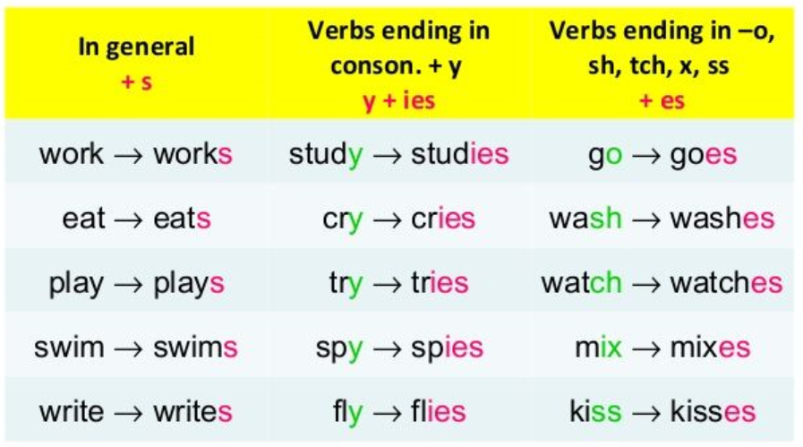

- Macarena is talking about Sofía´s school day. Complete with the verbs in exercise 5:
Sofía is a student at the Sagrado Corazón School in San Luis. She studies there from 1 PM to 6 PM. Every morning, Sofía wakes up and ____________ dressed in her bedroom. She __________ to music, too. She ____________ breakfast with her mum and brother, and then she ____________ her teeth. Sofía usually _________ her homework in the morning before school. She __________ to school at 12.30 PM.

- Complete the sentences with the affirmative or negative forms of the verbs in brackets:

- I usually have (have) a snack between lunch and dinner.
- She always _________ (have) a bath. She doesn´t have a shower.
- We finish school at 1 PM. We ______ (not go) to school in the afternoon.
- They do a lot of exercise, but they _____________ (not play) football.
- He ____________ (wash) his hair every morning, and he always brushes it, too.
- He´s got terrible teeth because he ____________ (not brush) them!

REMEMBER: To make questions: (wh/) + auxiliary verb + S + verb + …?

8. Complete the conversations: DO GO HAVE PLAY GET
1. What time do you get up?
I get up at 6.30 AM.
2. ________ your sister________ breakfast with you?
No, she ________. We hardly ever ________ breakfast together.
3. _________ your brother _________ exercise?
Yes, he ________. He __________ a lot of sport!
4. When ______ your sisters ________ football?
They __________ on Saturday mornings.
5. ________ you __________ to bed early?
No, I ___________ I often ________ to bed really late!

9.Write questions with the prompts:
1. you / get up / early?
Do you get up early? _____________________
2. how often / brush / your teeth
_____________________________________?
3. When / you / do / exercise
_____________________________________?
4. have / breakfast / with your family
______________________________________?
5. have / a snack / at school
______________________________________?

10. Now, write your routine at home. You can use some of these verbs:
Get up have breakfast do homework have lunch watch tv listen to music
Use the cell phone read a book have a shower brush my teeth have dinner
Hello! My name is _______________________________________________________
______________________________________________________________________
______________________________________________________________________
______________________________________________________________________
______________________________________________________________________

Recordá:
1. De ser posible realizá las actividades en el mismo archivo WORD o DRIVE que te mandamos, para vos y para nosotras será más ordenado el acceso.
2. Enviá un correo a tu seño con la resolución. (Miss. Coty matoconstanza@gmail.com, Miss. Dani ingles.danielacampi@outlook.com)
3. En el asunto del correo te pedimos que pongas tu nombre, apellido y el grado.
4. FECHA DE ENTREGA: hasta el miércoles 10 de junio.
5. Es MUY IMPORTANTE que guardes todas tus tareas y las correcciones en una carpeta de tu compu o impresas en tu carpeta de inglés.
Miss You a lot!

